Day #14 – Choosing your NAICS codes

Congratulations you’ve made it all the way to Day #14.

Choosing your NAICS codes can be a challenge if you don’t know what business to start.

If you are pondering consulting services, think about the type of client that you want to represent.

Find out how to do that and more in today’s lesson.
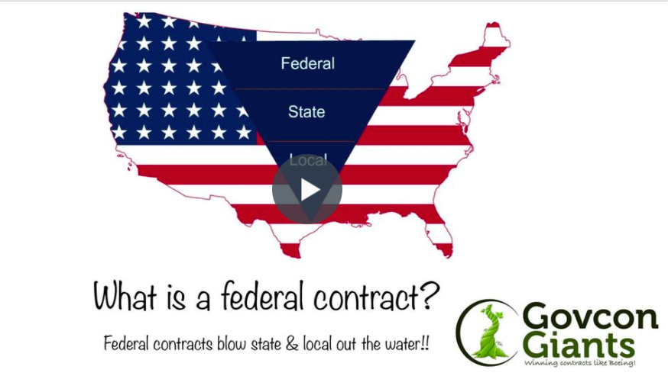

With more than $200 billion in disaster relief funds, there is more money circulating around than ever.

Don’t go back to your day job because of a few stumbling blocks.

Pick a name! Any name!

Big hug,

Eric Coffie

